American Association of Teachers of German, Inc.

112 Haddontowne Court #104, Cherry Hill, NJ 08034-3668
Telephone: 856-795-5553 Fax: 856-795-9398
E-mail: headquarters@aatg.org Web: www.aatg.org
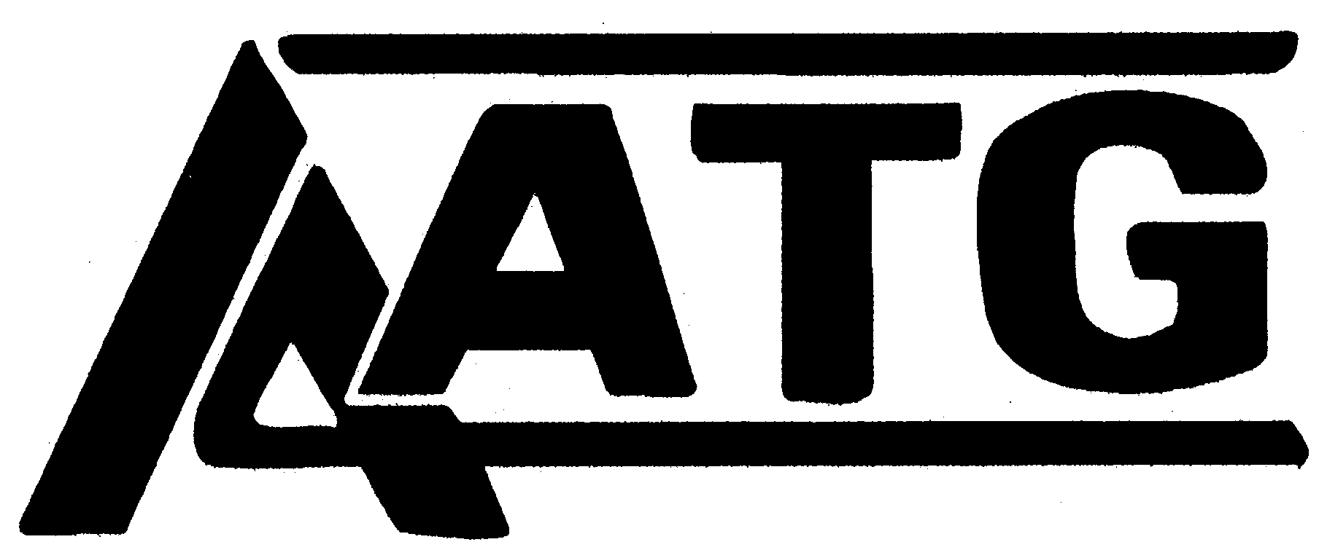

Serving teachers of German since 1926

German Immersion Camp
March 17-18, 2017
Camp Don Bosco, Carnation , WA
1401 327th Ave. NE
Carnation, WA 98014

German Immersion Camp is a 2 day event for advanced German students in Washington State. Students are expected to speak German the entire weekend and to participate in academic and cultural activities to enhance their German speaking ability and knowledge of German culture.

Cost per student: $60 for AATG members, $70 for non-members, $35 for exchange students and students on free and reduced lunch. Ratio of adult advisors to students: 1 to 8.

Please make checks out to AATG. All checks and purchase orders need to be sent to the AATG Treasurer: Rick Beck
3608 Bonnie Doone
Yakima, WA 98902

Camp Director: Susanne Kanning
Phone: 425-408-7271
Email: skanning@nsd.org

